Owner

Name_____________________________
Address______________________________________________________________
Home Phone________________________
Work Phone________________________
Cell Phone _________________________
E-Mail Address
__________________________________
Stable

Golden Oak Equestrian Center LLC
21290 Schulley Road
Noblesville IN 46062

(313) 605-7542

Golden.oak.equestrian@gmail.com
Lessee

Name_____________________________
Address______________________________________________________________
Home Phone________________________
Work Phone________________________
Cell Phone _________________________
E-Mail Address
__________________________________

Golden Oak Equestrian Center LLC
Boarding Contract

This agreement, dated this _____ day of __________, 20____ made by and between Golden Oak Equestrian Center LLC, hereinafter referred to as “STABLE”, providing services as an independent contractor, and ____________________________, hereinafter referred to as “OWNER”, owner of the hereinafter described horse, and __________________________________ hereinafter referred to as “LESSEE”, lessee of the hereinafter described horse. These parties warrant that they have the right to enter into this agreement.
Agreement purpose and Consideration
In consideration of $600 per horse per month paid by Owner/Lessee in advance on the _______day of each month, Stable agrees to board the herein described horse on a month to month basis commencing ________________________. Partial months boarding shall be paid on a pro-rata basis based on the number of days boarded in a standard 30-day month. A late fee of $20 per horse will apply for payments received after the five-day grace period along with a $5 per day per horse fee until such payments have been received. A fee of $25 will be applied for each returned check and checks will no longer be accepted as a form of payment. Payments not made in 30 days, will incur sale of said equine to pay board and applicable fees incurred, unless payment arrangements are made in writing. Any expenses and/or fees paid by Golden Oak Equestrian for client’s will incur a 10% surcharge.
Right of Lien
Stable shall be entitled to sell a lien against the horse and/or equipment stored upon Stable’s premises in the full amount due. Owner/Lessee warrants that it owns/leases said horse, that there are no liens against said horse, expressed or implied by law. The horse shall not be removed by Owner/Lessee, or by anyone at horse Owner/Lessee’s instruction, until payment in respect to all charges, including charges for services of others as ordered by Stable, on behalf of the horse Owner/Lessee, such as veterinary care, shall have been made. Stable shall have a general lien upon the Horse for payment of the sums owing for the services contemplated by this agreement. Such lien shall continue even if Horse is removed from the care, custody or control of Stable, and may be enforced as provided for enforcement of liens by the laws of the State of Indiana. Any legal action must be brought in the county of Hamilton, provided however, the parties agree to required mediation and arbitration of any disputes relating to this transaction. In the event it becomes necessary for Stable to commence litigation to enforce any of the terms of obligations of the horse Owner/Lessee under this agreement including the enforcement of any lien, Stable shall be entitled to recover all costs incurred, including reasonable attorney’s fees and any cost of repossession. Further, to secure performance of all obligations of this contract, horse Owner/Lessee grants Golden Oak Equestrian a security interest in the Horse.
Description of Horse
Name:____________________________ Color:_____________________ Breed:______________________
Sex:_____________________________ Age:_______ Tattoo No.:__________________________________
Insurance Carrier, Policy & Phone No.: ________________________________________________________
Schedule of Services
Stable agrees to provide the following, in addition to normal and reasonable care and handling to maintain the health and well-being of the animal: stall cleaning and bedding, grain (max. 10 lbs. per day) & hay (max. 8 flakes per day), use of pastures and facilities and turnout. In the event the aforementioned animal’s physical condition, as solely determined by Stable management, is considered unsuitable for showing or public representation of Stable, an additional feed fee shall be paid by Owner/Lessee. Additional feeding fees shall be based on $1.00 per one pound of grain or two (2) flakes of hay. Optional services available are as outlined in the Fee Schedule and shall be provided only after a written request of such desired services has been received by the Stable from the Owner/Lessee. The Owner/Lessee shall be solely responsible for the exercise of the horse and it is understood by Owner/Lessee that the horse will be turned out in selected groups as decided by Stable management. Furthermore, it is expressly recognized and understood that the boarding of said horse, as agreed to herein, is not a personal services contract and accordingly, any services provided for hereinafter may be performed by Stable or its employees, officers, agents and/or family members. Medications and supplements will only be administered after a Medication Administration Form has been completed and signed by both horse owner and Stable management.
Horse Health Warranty & Routine Care Requirement
Horse is/are free from infectious, contagious or transmissible disease(s), and will provide prior to time of delivery of said horse to Stable, proof satisfactory of a negative Coggins test current within the twelve-month period immediately preceding delivery of the horse to Stable. Owner/Lessee agrees to participate in effectively worming and keeping current on immunizations for this area, shoeing and teeth floating programs, the cost of which shall be borne by Owner/Lessee.
Emergency Care
Stable agrees to attempt to contact Owner/Lessee, utilizing the above listed phone number, should Stable feel that medical treatment is needed for said horse, provided however, that in the event the Stable is unable to contact Owner/Lessee within a reasonable time, which shall be judged and determined solely by Stable, Stable is then hereby authorized to secure emergency and routine veterinary care and/or blacksmith care, and by any licensed providers of such care who are selected by Stable, as Stable determines is required for the health and well-being of said horse. The cost of such care secured shall be due and payable by Owner/Lessee within 5 days from the date Owner/Lessee receives notice thereof. Stable is authorized to arrange direct billing by posted care provider to the Owner/Lessee. Owner/Lessee agrees to notify Stable of any and all changes of addresses, emergency telephone numbers, itineraries or other information reasonably necessary to contact Owner/Lessee in the event of an emergency. In the event Owner/Lessee departs for vacation or is otherwise unavailable, prior to departure Owner/Lessee shall notify Stable as to what party is authorized to make decisions in the Owner/Lessee’s place with regard to the health, well-being, and/or medical treatment of the horse.
Owner/Lessee’s Veterinarian (Name and Phone Number): _______________________________________________
Risk of Loss & Standard of Care
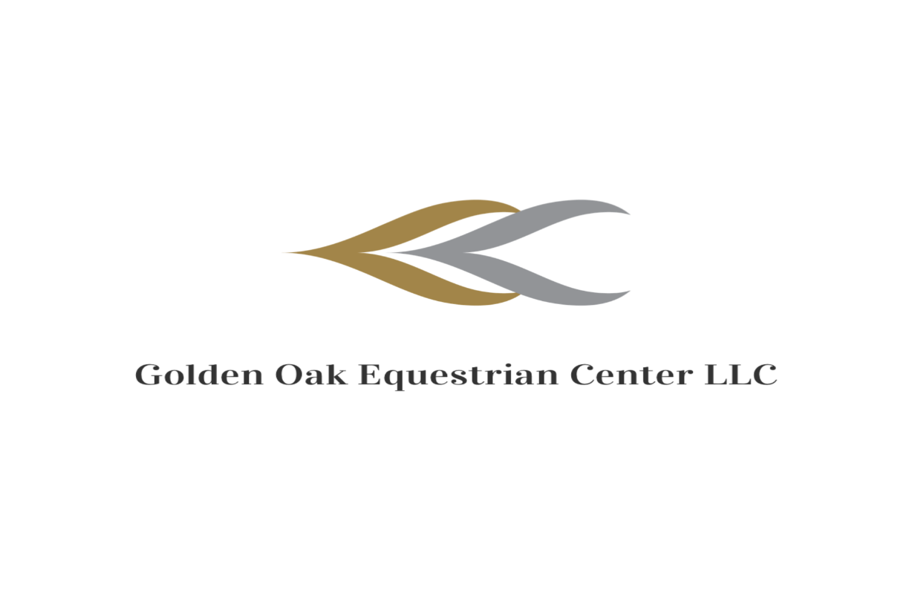
During the time that the horse is in the custody of Stable, Stable shall not be liable for any sickness, disease, theft, death or injury which may be suffered by the horse. This includes, but is not limited to, any personal injury or disability the horse may receive while on Stable’s premises. Owner/Lessee fully understands and hereby acknowledges that Stable does not carry any insurance of any horse not owned by Stable, including but not limited to, such insurance for boarding or any other purposes, for which the horse is covered under any public liability, accidental injury, theft or equine mortality insurance, and that all risks relating to boarding of horse, or for any other reason, for which horse is in the possession of Stable, are to be borne by Owner/Lessee. The standard of care applicable to Stable is that of ordinary care of a prudent animal owner and not as a compensated Bailee. In no event shall Stable be held liable to Owner/Less for equine death or injury in an amount in excess of five thousand dollars ($5,000) per animal. Owner/Lessee agrees to obtain equine insurance for any animals valued in excess of five thousand dollars ($5,000), at Owner/Lessee’s expense, or forego any claims for amounts in excess of five thousand dollars ($5,000). Owner/Lessee agrees to disclose this entire agreement to Owner/Lessee’s insurance company and provide Stable with the company’s name, address and policy number. Failure to disclose insurance information shall be at Owner/Lessee’s risk.
Owner Acceptance of Responsibility
During the time that the horse is being boarded, the horse shall be in the custody of the Stable. Owner/Lessee has inspected the Stable's premises and/or has in some other way satisfied himself that the conditions of the premises and the facilities will provide an adequate and reasonable level of safety for Owner/Lessee's horse. Owner/Lessee further agrees to be responsible for any and all damages, injuries and/or loss of life caused by or to the animal while in the control of the Owner/Lessee, Owner/Lessee’s family members, invitees or other handlers or agents appointed by them, and also for any acts of the horse caused by vices or dangerous behavior not disclosed to the Stable by Owner/Lessee. Owner/Lessee is also responsible for accidents, injuries, and loss of life sustained by Owner/Lessee, Owner/Lessee’s family members, invitees and agents caused by or in relation to the Owner/Lessee’s horse. The Owner/Lessee will have use of designated tack rooms to store their equipment. Owner/Lessee is hereby warned that direct loss or damage, theft, injury or disappearance of Owner/Lessee’s horses, tack, equipment or other property is not covered by Stable’s insurance and Stable shall not be liable for Owner/Lessee’s horses, tack, equipment or other property. The Owner/Lessee must tidy the Stable’s equipment and premises after use. The property is open between the hours of 8am and 9pm Monday through Sunday. The Owner/Lessee must seek permission of the Stable to be on the premises outside of these hours.
Release of Liability
In consideration of Stable undertaking the incidental services under the terms set forth herein, I, the undersigned Owner/Lessee, do agree to hold harmless and release the Stable, Stable's owners, agents, employees, officers, directors, representatives, assigns, members, premises owners, affiliated organizations, and Insurers, and others acting on Stable's behalf (hereinafter collectively referred to as "Associates"), of all claims, demands, causes of action, and legal liability, whether the same be known or unknown, anticipated or unanticipated, due to Stable's and or Stable's Associates ordinary negligence; and I do further agree that except in the event of the Stable's gross negligence and willful and wanton misconduct, I shall not bring any claims, demands, legal actions and causes of action, against the Stable and Stable's Associates as stated above in this clause, for any economic and non-economic losses due to bodily injury, death, property damage, and injury to the animals and/or by me and/or by my minor child or legal ward, in relation to the premises and operations of the Stable.
Stable Rules
Owner/Lessee hereby acknowledges receipt and understanding of the current STABLE RULES, which are incorporated by reference in full, as if fully set forth herein. Owner/Lessee agrees he and his guests and invitees will be bound and abide by these Rules, and accepts responsibility for the conduct of his guests and invitees according to these Rules. Owner/Lessee acknowledges the Rules include but are not limited to: Stable Rules & Stable Hours of Operation; Riding Instruction & Liability Release; Statement of Applicable State Equine Liability Laws and Fee Schedule. Stable may revise these Rules from time to time and Owner/Lessee agrees any revision shall have the same force and effect as current Rules. Failure, as determined in Stable's sole discretion, of Owner/Lessee or Owner/Lessee's guests and invitees to abide by Stable Rules may result in Stable declaring Owner/Lessee in default hereunder and result in termination of this agreement.
Assignment
This Agreement may not be assigned by Owner/Lessee without the express written consent of Stable.
Term
This agreement will extend for a term commencing on the date hereof and ending on the Horse's departure, unless terminated pursuant to the provisions in sub-paragraphs A, B, or C as set forth below in paragraph 12:
- Default: If the horse Owner/Lessee or Stable defaults in the performance of their respective obligations hereunder, and such default continues for thirty days(30) after written notice specifying such default, then, in that event, this Agreement, at the option of the non-defaulting party, may be terminated by written notice at any time thereafter which such default continues, provided however, that if such default is cured, or, with respect to defaults requiring action other than the payment of money, if action to cure such default is undertaken within said thirty (30) day period and diligently pursued to completion, then this Agreement will continue as if the notice of default had not been served.
- Mutual Agreement: This agreement may otherwise be immediately terminated prior to the specified termination date, as described herein, by mutual agreement of the horse Owner/Lessee and Stable. In the event, horse Owner/Lessee and Stable shall mutually arrange and agree upon such termination.
- One Party Termination: This agreement may also be terminated by the horse Owner/Lessee or by Stable with thirty (30) day advance notice by certified mail made by the party seeking termination to the other party. Stable will upon termination of this Agreement, at the horse Owner/Lessee’s sole expense: 1. Surrender to the horse Owner/Lessee the records, if any, associated with the boarding of the horse, 2. Surrender the horse to the horse Owner/Lessee. The horse Owner/Lessee will upon termination of this Agreement: 1. Make prompt and immediate payment in the form of cash, cashier’s check, or bank money order, in the amount equal to any and all remaining expenses due on account relating to the Horse which are due payable up to and including the date of the horse’s departure from the Stable, prior to the Stable’s required release of the horse, 2. The horse Owner/Lessee shall, upon termination of this Agreement, release Stable from all further obligations of any sort relating to the horse and/or the Owner/Lessee .
This Agreement constitutes the entire Agreement between the parties. Any modifications, additions or submissions must be in writing signed by all parties to this Agreement. No oral modifications will be considered part of this Agreement unless reduced to writing and signed by all parties. This agreement is subject to the Laws of the State of Indiana, executed at Westfield Indiana on the date first set forth above.

“Stable” Golden Oak Equestrian Center LLC DATE_____________ “Owner” _______________________________ (Sign) DATE___________________

“Lessee”____________________________________________ (Sign) DATE___________________

